Date: 06/09/2020

Sponsor contact block - enter name, address, email as appropriate

RE: CHANGE IN RESEARCH IN RESPONSE TO COVID-19

Principal Investigator: last name, first name
Sponsor: enter sponsor name | Sponsor Award #: ########
Award Dates: – | UNC Project ID: ########

To Whom It May Concern:

Beginning Friday, March 20, 2020 and until further notice, the University of North Carolina at Chapel Hill (University) significantly reduced operations on campus as a response to the COVID-19 outbreak. Research that can be conducted remotely is encouraged as much as possible in order to enable the University’s research enterprise to continue its important work. However, this letter demonstrates the effect of COVID-19 on the research efforts of the award identified above in order to comply with University and State guidance.

Summary of University guidance to reduce research operations
Under the University’s reduced operations guidance, laboratory-based research is restricted to “critical research activities” and all labs and cores without this designation were to have ramped down operations effective March 25. Human subjects research visits (involving direct contact) are postponed unless the visit provides immediate benefit to the health or well-being of the participant. The Division of Comparative Medicine continues to provide care and support for research animals; however, non-essential experiments are postponed until normal operations resume on campus. Research and related administrative activities that can be conducted remotely continue to be performed. In addition, all University compliance offices continue to operate to support the campus research community and maintain ongoing compliance.

Completed by the Principal Investigator
Was the above referenced project impacted by University guidance to reduce operations? YES or NO
If you answer YES, in the section(s) below, describe the nature of the impact and any anticipated delays. If you answer NO, describe why there was no impact (i.e., research activity was deemed critical). Delete any sections below not applicable to this project/award.

Impact to Research
enter response

Anticipated delays: enter response

Impact to Human Subject Research - UNC IRB Protocol(s): ##-####
enter response

Anticipated delays: enter response

Impact to Animal Subject Research - UNC IACUC Protocol(s): ##-####
enter response

Anticipated delays: enter response

In accordance with federal agency and University policy, the University will continue to charge salaries to eligible financial assistance awards. If you have any questions with the information in this letter and/or need further clarification, please contact the Office of Sponsored Research via email at ResAdminOSR@unc.edu.

Sincerely,

Principal Investigator: Authorizing Official:

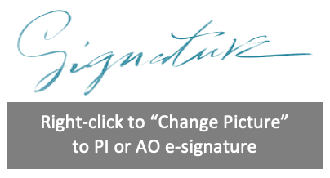
enter PI's full name | Terry Magnuson, PhD
enter PI's title | Vice Chancellor for Research
enter PI's email | ResAdminOSR@unc.edu

